**Pulse Sensor Getting Started Guide**

脉冲传感器启动指南

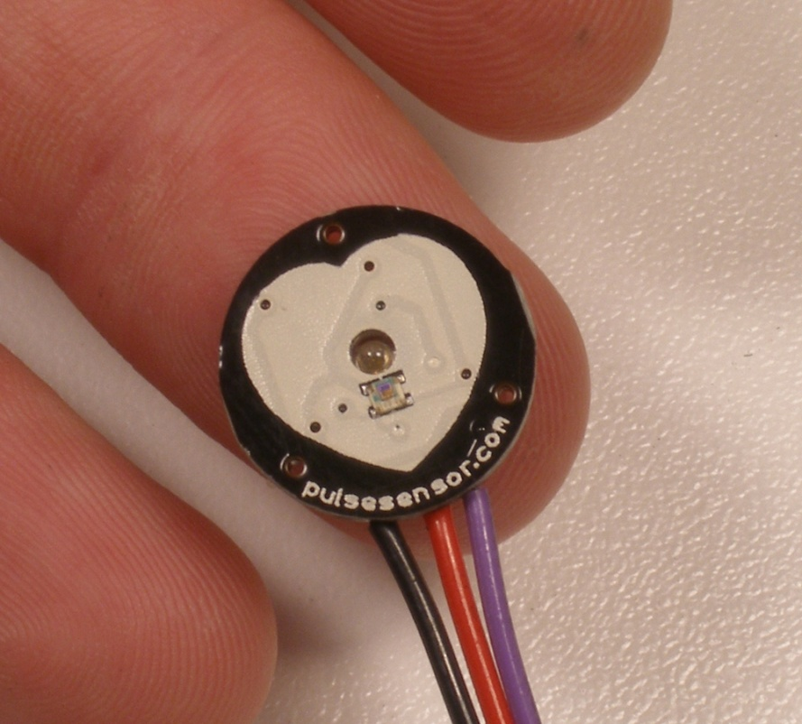

## Introduction: 作品简介

Pulse Sensor is a well-designed plug-and-play heart-rate sensor for Arduino. It can be used by students, artists, athletes, makers, and game & mobile developers who want to easily incorporate live heart-rate data into their projects. The sensor clips onto a fingertip or earlobe and plugs right into Arduino. It also includes an open-source monitoring app that graphs your pulse in real time.

Pulse Sensor是一款为Arduino设计的即插即用的心率传感器。它可以被学生、艺术家、运动员、创造者、游戏和移动开发者所使用，他们希望能够轻松地将实时心率数据整合到他们的项目中。传感器固定在指尖或耳垂上，然后直接插入Arduino。它还包括一个开源监测应用程序，可以实时绘制你的脉搏。

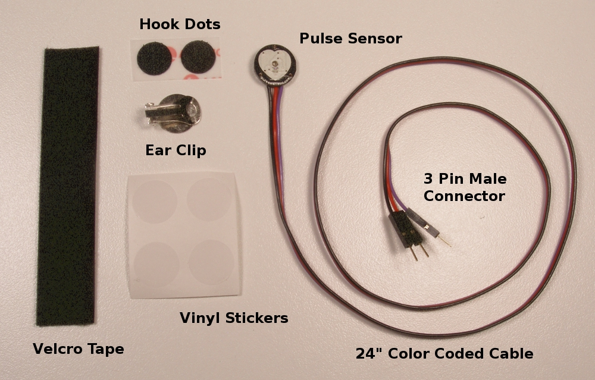

The Pulse Sensor Kit includes:

脉冲感应组件包括:

1) A 24-inch Color-Coded Cable, with (male) header connectors. You'll find this makes it easy to embed the sensor into your project, and connect to an Arduino. No soldering is required.

1) 24英寸彩色编码电缆，带(公)头连接器。您会发现，这样可以很容易地将传感器嵌入到您的项目中，并连接到Arduino。不需要焊接。

2) An Ear Clip, perfectly sized to the sensor. We searched many places to find just the right clip. It can be hot-glued to the back of the sensor and easily worn on the earlobe.

2)一个耳夹，大小与传感器完全匹配。为了找到合适的片段，我们找了很多地方。它可以热粘在传感器的背面，很容易戴在耳垂上。

3) 2 Velcro Dots. These are 'hook' side and are also perfectly sized to the sensor. You'll find these velcro dots very useful if you want to make a velcro (or fabric) strap to wrap around a finger tip.

3) 2维可牢尼龙搭扣圆点。这些是'钩'侧，也是完美大小的传感器。你会发现这些维可牢尼龙搭扣非常有用，如果你想做一个维可牢尼龙搭扣(或织物)带缠绕在指尖上。

4) Velcro strap to wrap the Pulse Sensor around your finger.

4)尼龙搭扣带将脉冲传感器缠绕在手指上。

4) 3 Transparent Stickers. These are used on the front of the Pulse Sensor to protect it from oily fingers and sweaty earlobes.

4) 3张透明贴纸。这些用于脉冲传感器的前端，以保护它免受油腻的手指和汗湿的耳垂。

5) The Pulse Sensor has 3 holes around the outside edge which make it easy to sew it into almost anything.

5)脉冲传感器的外缘有3个孔，这使得它很容易缝进几乎任何东西。

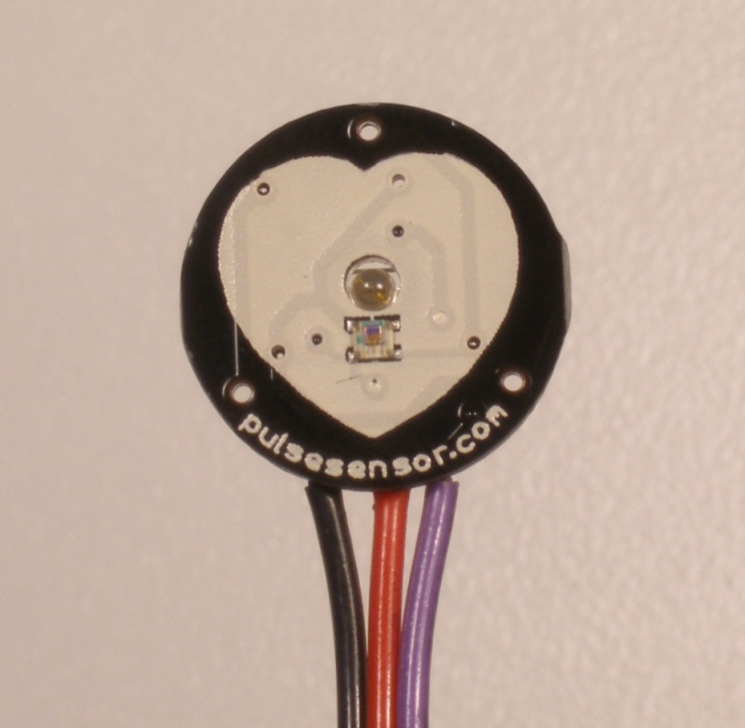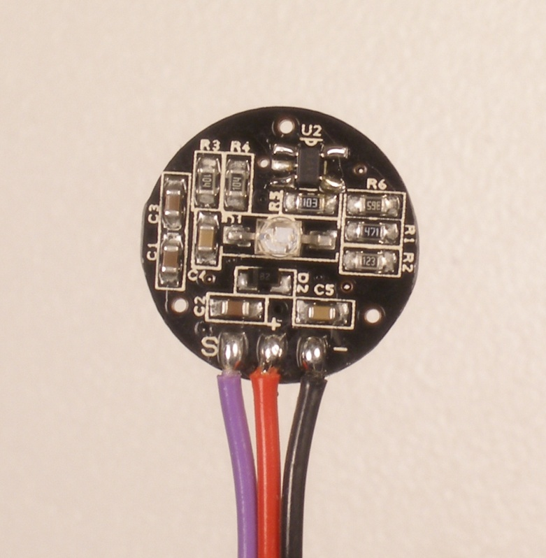

## Let’s get started with Pulse Sensor Anatomy

## 让我们从脉冲传感器解剖开始

The front of the sensor is the pretty side with the Heart logo. This is the side that makes contact with the skin. On the front you see a small round hole, which is where the LED shines through from the back, and there is also a little square just under the LED. The square is an ambient light sensor, exactly like the one used in cellphones, tablets, and laptops, to adjust the screen brightness in different light conditions. The LED shines light into the fingertip or earlobe, or other capillary tissue, and sensor reads the amount of light that bounces back. The other side of the sensor is where the rest of the parts are mounted. We put them there so they would not get in the way of the of the sensor on the front. Even the LED we are using is a reverse mount LED. For more about the circuit functionality, check out the [Open Hardware](http://pulsesensor.myshopify.com/pages/open-hardware) page.

The cable is a 24” flat color coded ribbon cable with 3 male header connectors.

传感器的前面是漂亮的一面与心的标志。这是与皮肤接触的一面。在前面你可以看到一个小圆洞，这是发光二极管从后面照进来的地方，在发光二极管下面也有一个小正方形。这个正方形是一个环境光传感器，与手机、平板电脑和笔记本电脑使用的环境光传感器完全一样，可以在不同的光线条件下调整屏幕亮度。LED将光线照射到指尖、耳垂或其他毛细血管组织，传感器读取反射回来的光量。传感器的另一侧是其余部分安装的地方。我们把它们放在那里，这样它们就不会妨碍前面的传感器。甚至我们使用的LED也是反向安装的。有关电路功能的更多信息，请参阅开放硬件页面。

该电缆是一种24 "平彩色编码带电缆与3个男性头连接器。

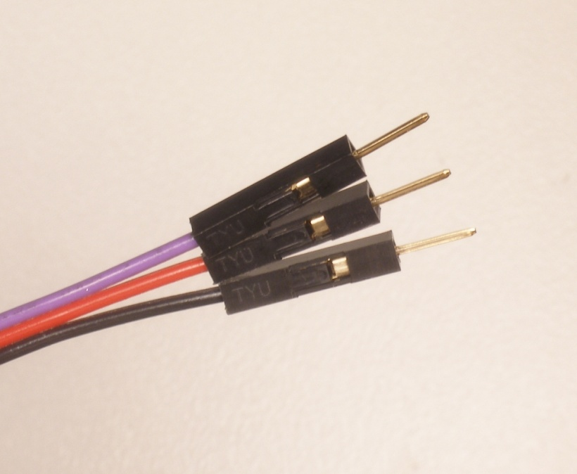RED wire = +3V to +5V

BLACK wire = GND

PURPLE wire = Signal

红线= +3V到+5V

黑线= GND

紫线=信号

The Pulse Sensor can be connected to arduino, or plugged into a breadboard. Before we get it up and running, we need to protect the exposed circuitry so you can get a reliable heartbeat signal.

脉冲传感器可以连接arduino，也可以插到面包板上。在我们启动和运行它之前，我们需要保护暴露的电路，这样你才能得到可靠的心跳信号。

## Preparing the Pulse Sensor

脉冲传感器的研制

Before you really start using the sensor you want to insulate the board from your (naturally) sweaty/oily fingers. The Pulse Sensor is an exposed circuit board, and if you touch the solder points, you could short the board, or introduce unwanted signal noise. We will use a thin film of vinyl to seal the sensor side. Find the small card with four clear round stickers in your kit, and peel one off. Then center it on the Pulse Sensor. It should fit perfectly.

在你真正开始使用传感器之前，你要把板与你(自然)出汗/油腻的手指隔离。脉冲传感器是一个暴露的电路板，如果你接触到焊点，你可能会短路电路板，或引入不必要的信号噪声。我们将使用一层乙烯基薄膜来密封传感器。在你的工具箱里找一张小卡片，上面有四张清晰的圆形贴纸，撕掉一张，然后把它放在脉冲传感器上。它应该非常合适。

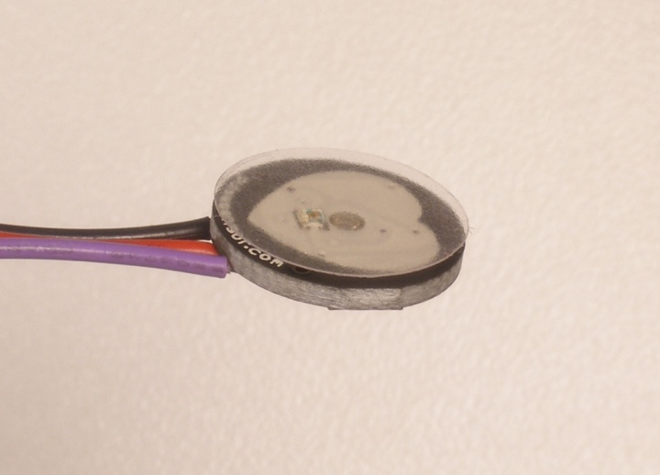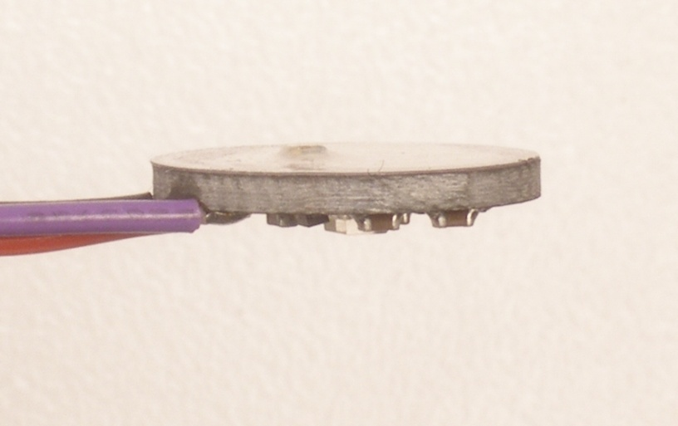

When you are happy with the way it’s lined up, squeeze it onto the face all at once! The sticker (made of vinyl) will kind of stretch over the sensor and give it a nice close fit. If you get a wrinkle, don’t worry, just press it down really hard and it should stick. We gave you 4, so you can replace it if necessary.

That takes care of the front side. The vinyl sticker offers very good protection for the underlying circuit, and we rate it ‘water resistant’. meaning: it can stand to get splashed on, but don’t wear it in the pool!

If this is your first time working with Pulse Sensor, you’re probably eager to get started, and not sure if you want to use the ear-clip or finger-strap (or other thing of your design). The back of the Pulse Sensor has even more exposed contacts than the front, so you need to make sure that you don’t let it touch anything conductive or wet.

The easiest and quickest way to protect the back side from undesirable shorts or noise is to simply stick a velcro dot there for now. The dot will keep your parts away from the Pulse Sensor parts enough for you to get a good feel for the sensor and decide how you want to mount it. You’ll find that the velcro dot comes off easily, and stores back on the little strip of plastic next to the other one we gave you.

当你对它的排列方式感到满意时，马上把它挤到脸上!贴纸(乙烯基制成)会延伸到传感器上，使其非常贴合。如果你有了皱纹，不要担心，把它压得很紧就可以了。我们给你4个，如果有必要你可以换一个。

它负责前面的部分。乙烯基贴纸为底层电路提供了很好的保护，我们认为它“防水”。含义:它可以被泼到身上，但不要在泳池里戴着它!

如果这是您第一次使用脉冲传感器，那么您可能急于开始使用它，但不确定是否要使用耳夹或指带(或您设计的其他东西)。脉冲传感器的背面比正面有更多的暴露接触，所以你需要确保不要让它接触任何导电或潮湿的东西。

保护背部不受不良短裤或噪音影响的最简单和最快的方法就是现在就在那里粘一个维可牢尼龙搭扣。点将使您的部分远离脉冲传感器的部分，足以让您获得良好的感觉传感器，并决定您想要如何安装它。你会发现，维可牢尼龙搭扣很容易脱落，并储存在我们给你的那一小块塑料上。

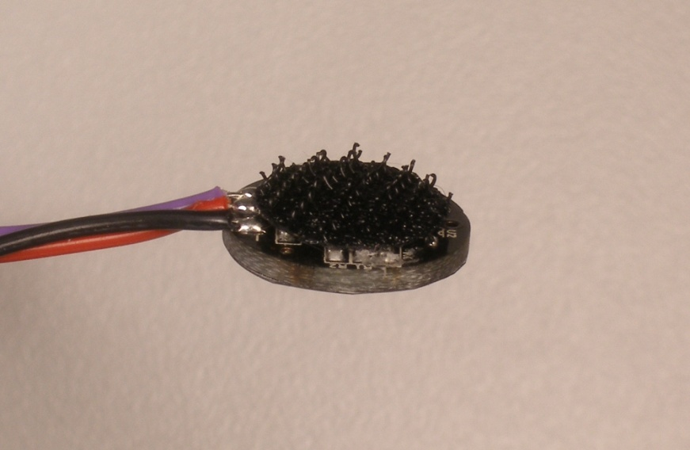

Notice that the electrical connections are still exposed! We only recommend this as a temporary setup so you can get started. We show you how to better seal the Pulse Sensor later in this document.

注意，电气连接仍然是暴露的!我们只建议这是一个临时设置，这样您就可以开始了。我们将在稍后的文档中向您展示如何更好地密封脉冲传感器。

**Running The Pulse Sensor Arduino Sketch**

运行脉冲传感器Arduino示意图

Get the latest Arduino software here（这里有最新的Arduino软件） ：<https://github.com/WorldFamousElectronics/PulseSensorPlayground>

Follow the [README](https://github.com/WorldFamousElectronics/PulseSensorPlayground/blob/master/README.md) guide to get set up, or follow this（按照README指南进行设置，或者按照这个） ：

[Getting Started Tutorial](https://pulsesensor.com/pages/code-and-guide)

For Arduino IDE download（Arduino IDE下载）: <https://www.arduino.cc/en/Main/Software>

We strongly advise that you DO NOT connect the Pulse Sensor to your body while your computer or arduino is being powered from the mains AC line. That goes for charging laptops and DC power supplies. Please be safe and isolate yourself from from the power grid, or work under battery power.

Connect the Pulse Sensor to: +V (red), Ground (black), and Analog Pin 0 (purple) on your favorite Arduino, or Arduino compatible device, Then find the Getting Started sketch by clicking

**File > Examples >PulseSensor Playground >A_StarterProject_and_SignalTester**

我们强烈建议您不要在您的电脑或arduino由交流电源供电时将脉冲传感器连接到您的身体上。用于给笔记本电脑和直流电源充电。请注意安全，远离电网，或使用电池供电。

将脉冲传感器连接到:+V(红色)，接地(黑色)，和您喜欢的Arduino或Arduino兼容的设备上的模拟引脚0(紫色)，然后点击文件> Examples >PulseSensor Playground >A_StarterProject_and_SignalTester找到入门示意图

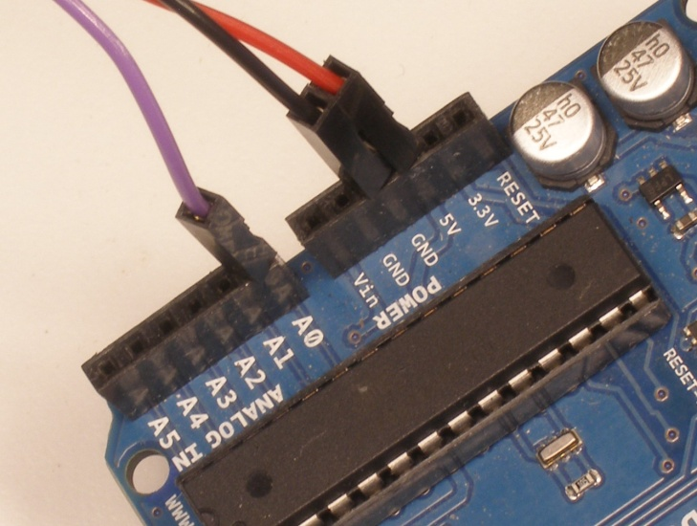

After it’s done uploading, you should see Arduino pin 13 blink in time with your heartbeat when you hold the sensor on your fingertip. If you grip the sensor too hard, you will squeeze all the blood out of your fingertip and there will be no signal! If you hold it too lightly, you will invite noise from movement and ambient light. Sweet Spot pressure on the Pulse Sensor will give a nice clean signal. You may need to play around and try different parts of your body and pressures. If you see an intermittent blink, or no blink, you might be a zombie or a robot. With your Arduino connected to your computer, you can visualize the pulse waveform easily by using the Arduino Serial Plotter. Click on **Tools > Serial Plotter** to launch this tool. In the lower right hand there is a drop-down menu to select the baud rate. Make sure that this is set to **9600**, or you won’t see anything! Here’s an image of what the Serial Plotter plots.

上传完成后，当你将传感器放在指尖上时，你会看到Arduino 13脚随着你的心跳一起闪烁。如果你把传感器抓得太紧，你会把指尖的血都挤出来，就没有信号了!如果你握得太轻，你会受到运动和周围光线的干扰。脉冲传感器上的最佳点压力将给出一个清晰的信号。你可能需要尝试不同的身体部位和压力。如果你看到一个间歇性的眨眼，或没有眨眼，你可能是一个僵尸或机器人。只要将Arduino连接到电脑上，就可以使用Arduino串口绘图机，轻松地将脉冲波形显示出来。单击工具>串行绘图仪启动此工具。在右下角有一个下拉菜单来选择波特率。请确保将此设置为9600，否则您将看不到任何内容!这是串行绘图仪绘制的图像。

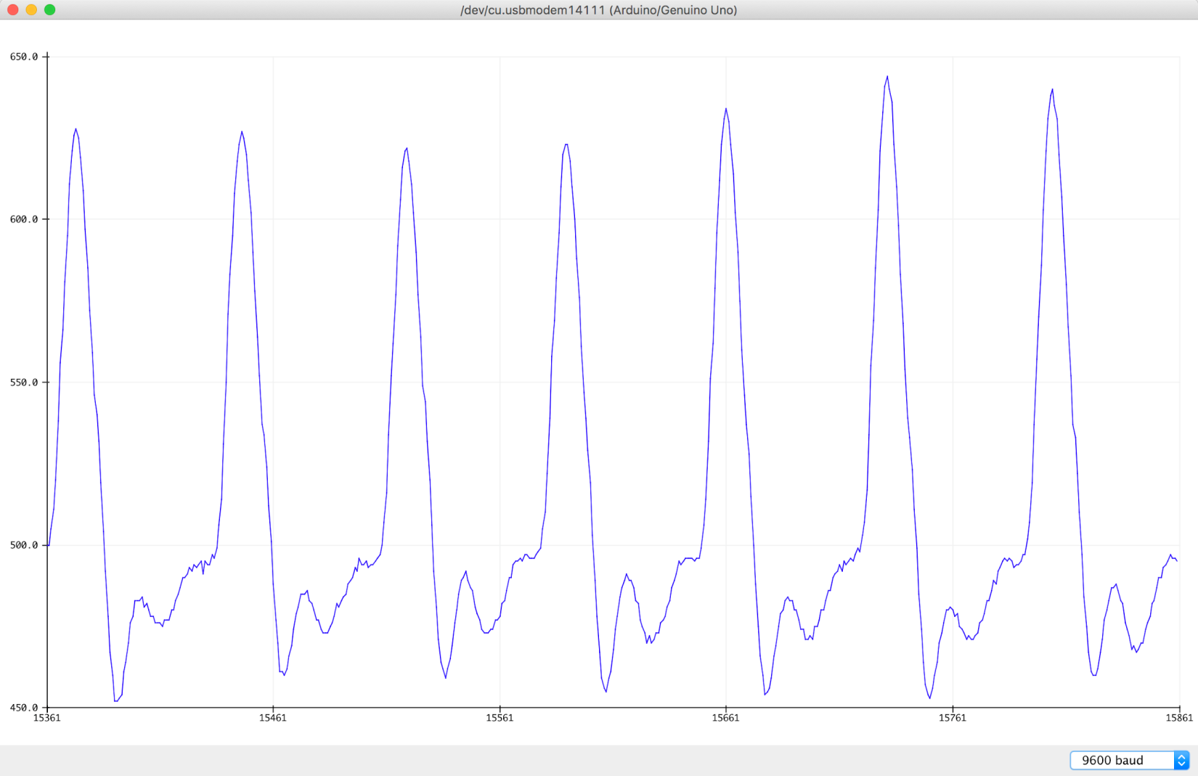

**Sealing the Back Side of Pulse Sensor**

**Basic protection for the back of the Pulse Sensor**

**and prep for attaching Velcro Dot.**

**密封脉冲传感器背面**

**脉冲传感器背面的基本保护**

**准备好粘上维可牢尼龙搭扣**

It’s really important to protect the exposed Pulse Sensor circuitry so the sweat of your fingertips or earlobe (or wherever) doesn’t cause signal noise or a short circuit. This How-To uses hot glue, which can be removed easily or re-worked if you want to change where you’ve stuck your Pulse Sensor. We love hot glue!

The other things you’ll need are:

保护暴露在外的脉冲传感器电路是非常重要的，这样你的指尖或耳垂(或其他地方)的汗水就不会引起信号噪音或短路。这是如何使用热胶，可以很容易地删除或重新工作，如果你想改变你把你的脉冲传感器。我们喜欢热胶!

你还需要:

Hot Glue Gun

Blue Tape (any tape should do ok)

Nail Trimmers (or your favorite trimming device. Flush-cut wire snips work well too)

Read these instructions all the way through before you start!

热熔胶枪

蓝色胶带(任何胶带都可以)

指甲修剪器(或者你最喜欢的修剪设备)。平头剪钢丝剪也很好用)

在你开始之前，把这些说明通读一遍!

First, attach the clear vinyl sticker to the front of your Pulse Sensor, as shown above. Then put a blob of hot glue on the back, right over the circuit. Size can be difficult to judge sometimes. What I meant was put a hot glue blob about the size of a kidney bean on the back side of the Pulse Sensor.

首先，把清晰的乙烯基贴纸贴在你的脉冲传感器前面，如上所示。然后在背面涂上一团热胶，就在电路的正上方。规模有时很难判断。我的意思是在脉冲传感器的背面放一个肾豆大小的热胶团。

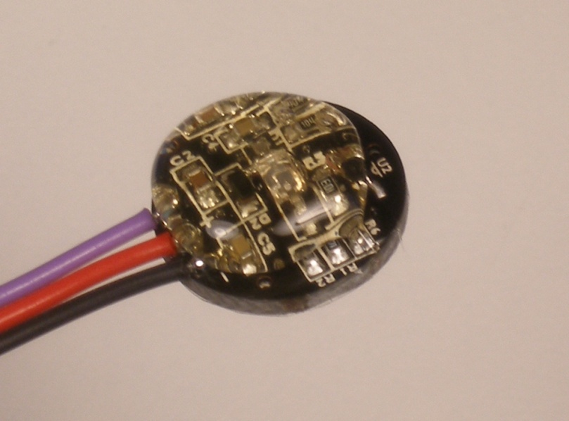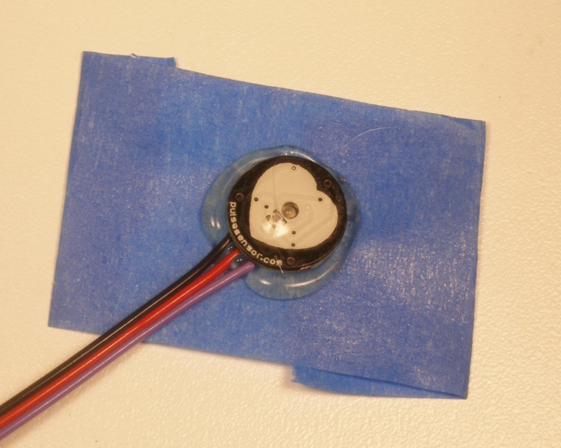

Then, while the glue is still very hot, press the Pulse Sensor glue-side-down onto the sticky side of a piece of blue tape (We believe that blue tape has magical properties, but if you don’t have blue tape other kinds of tape will work just as well).

然后，当胶水还很热的时候，把脉冲传感器倒着按在蓝色胶带的粘性上(我们相信蓝色胶带有神奇的属性，但是如果你没有蓝色胶带，其他类型的胶带也可以)。

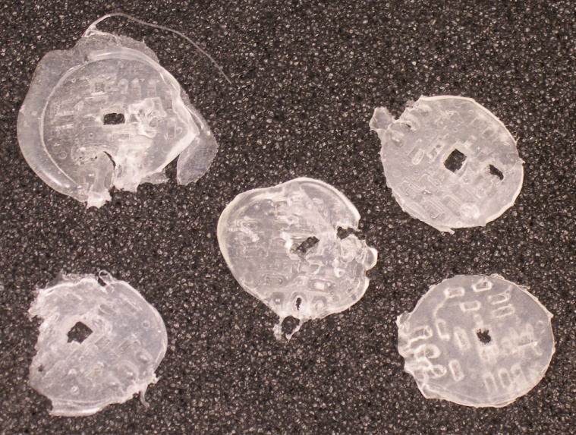

***note***: The tallest thing on the back of the Pulse Sensor is the green LED housing right in the middle. Use it to make the hot-glue seal thin and strong. When you press evenly until the back of the LED touches, all the conductive parts will be covered with hot glue. If the glue doesn’t ooze out all around, let it cool down, then peel if from the Pulse Sensor and try again. Once the glue has cooled down and has some body, you can peel it off easily. Here’s some pics of hot glue ‘impressions’ that I took during the making of this guide.

注:脉冲传感器背面最高的东西是正中间的绿色LED外壳。用它使热胶密封薄而坚固。当你均匀地按压直到LED的背面接触时，所有的导电部分都会被热胶覆盖。如果胶水没有到处渗出，让它冷却下来，然后从脉冲传感器上剥落，再试一次。一旦胶水冷却下来，有了一些主体，你可以很容易地把它剥下来。这里有一些热胶“印象”的照片，是我在制作这个指南时拍摄的。

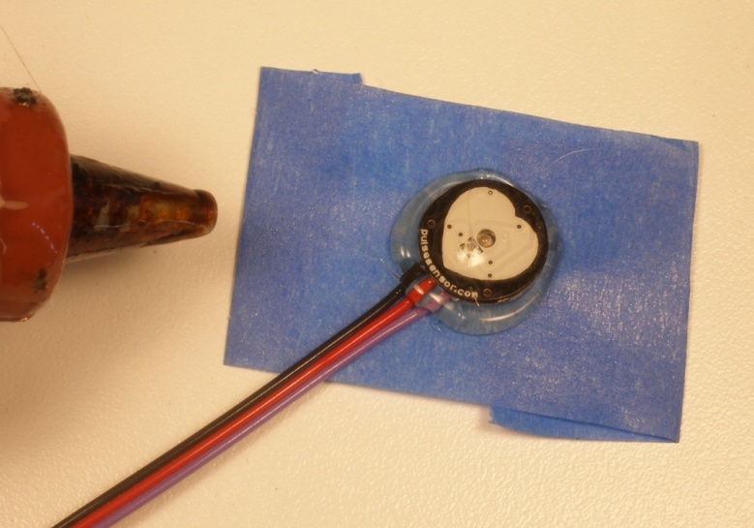

Next put a small dab of hot glue on the front

of the cables, where they attach to the Pulse

Sensor circuit board. This will bond to the other

glue that’s there and act as a strain-relief for the

cable connection. This is important because the

cable connection can wear out over time.

接下来在正面涂一小块热胶

连接到脉冲的电缆

传感器电路板。这个会和另一个结合

胶水就在那里，起到缓解压力的作用

电缆连接。这很重要，因为

电缆连接可能会随着时间的推移而磨损。

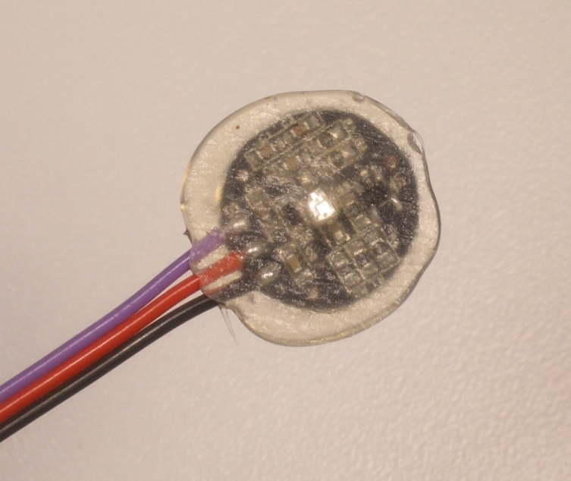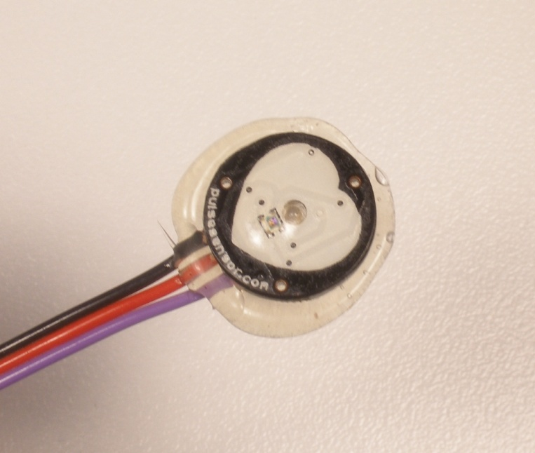

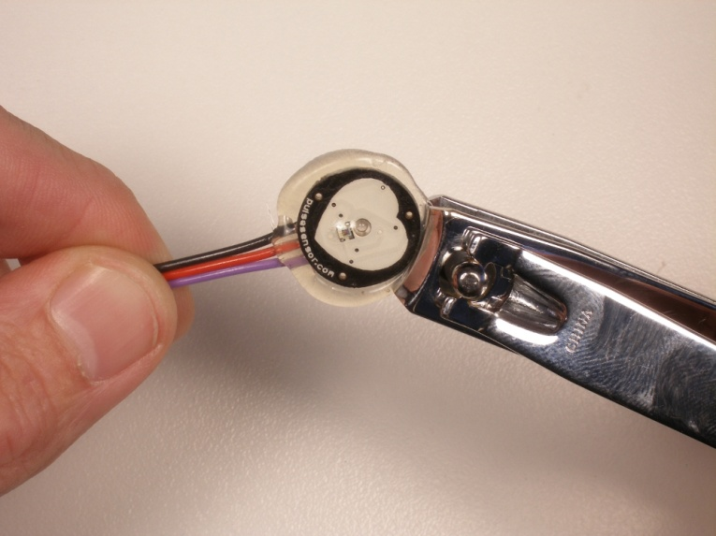

Once the hot glue has cooled (wait for it!)

the blue tape will peel off very easily. Check

your work to make sure that there are not

exposed electrical connections!

Next is trimming. I find the easiest way is to

use nail clippers. Flush cutting wire snips work

too. Take care not to clip the wires!!!

And leave enough around the cable to act

as a good strain-relief

一旦热胶冷却(等一下!)

蓝色的带子很容易脱落。检查你的工作要确保没有电气连接暴露了!下一个是修剪。我发现最简单的方法是使用指甲钳。齐平切割电线剪工作了。小心别把电线夹断了!!在电缆周围留足够的空间来行动作为一个很好的应变缓解

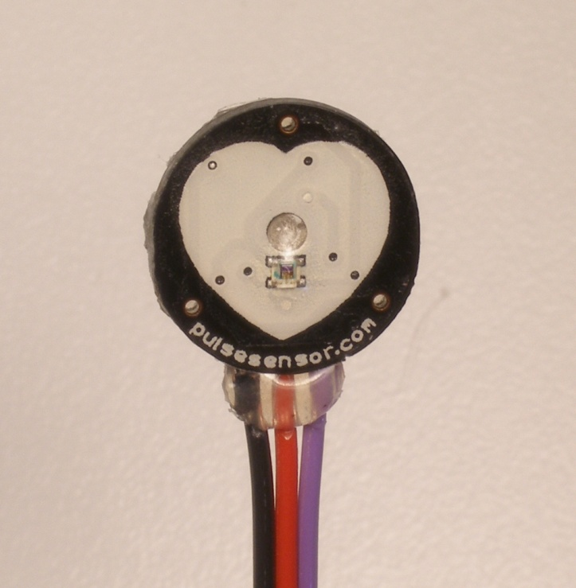

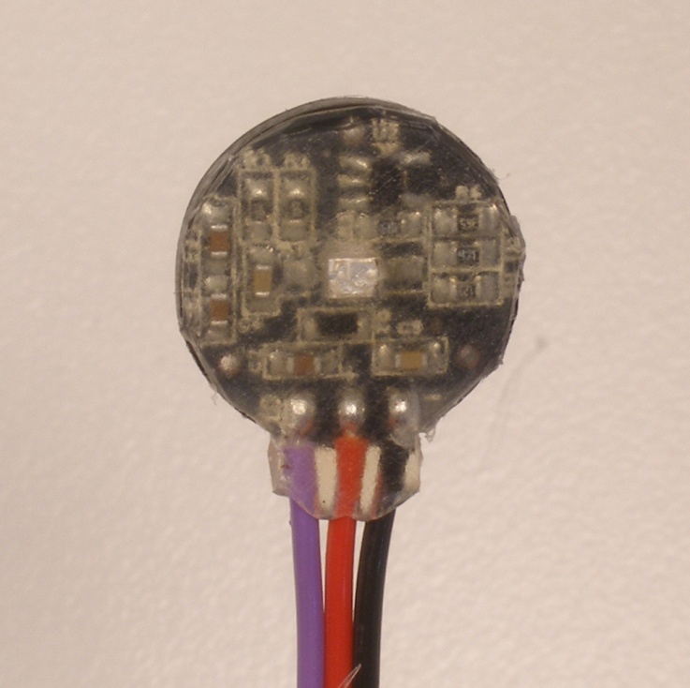

This is the basic Pulse Sensor Hot Glue Seal, It’s also got the clear vinyl sticker on the front face. We’re calling this ‘Water Resistant’, ready to be handled and passed around from fingers to earlobes or whatever. It is not advised to submerge or soak the Pulse Sensor with this basic seal.

Now you can stick on the velcro dot (included) and make a finger strap with the velcro tape (included)!

这是基本的脉冲传感器热胶密封，它也有清晰的乙烯基贴纸在正面。我们称它为“防水的”，可以用手拿着，从手指传到耳垂或其他部位。不建议将带有这种基本密封的脉冲传感器浸入或浸泡。

现在你可以粘上维可牢尼龙搭扣点(包括)，用维可牢尼龙搭扣带做一个手指带(包括)!

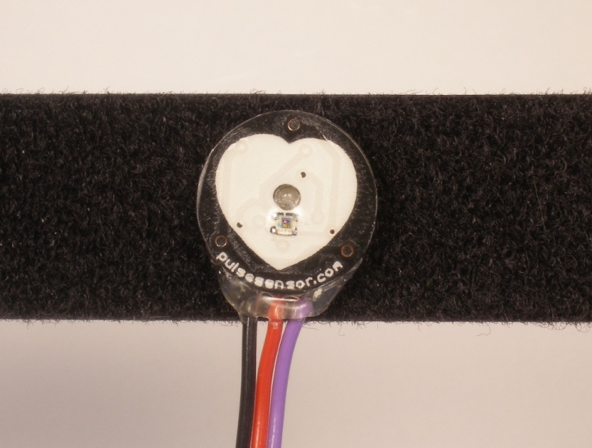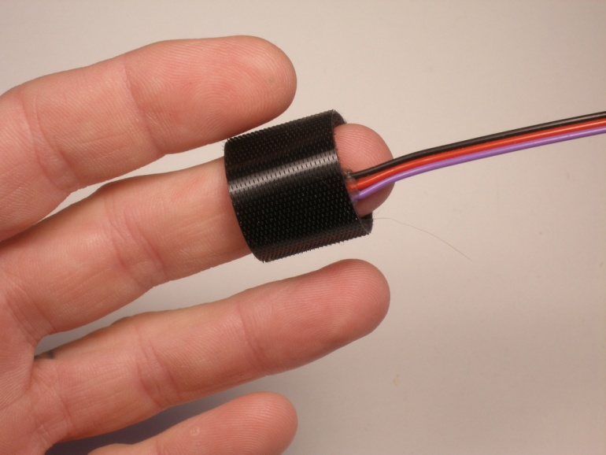

**Attaching the Ear Clip**安装耳夹

We looked all over, and were lucky enough to find an ear clip that fits the Pulse Sensor perfectly. The earlobe is a great place to attach Pulse Sensor. Here’s some instruction on how to do it.

It is important to apply some strain relief to the cable connection where it meets the Pulse Sensor PCB. The little wire connections can wear out and break (or short on something) over time. We can do this with hot glue, like we did in the previous example.

First, attach a clear vinyl sticker to the front of the Pulse Sensor if you have not already. Then, put a small dab of hot glue on the front of the cables right where they meet the PCB. Get some on the edge of the PCB too, that will help. Remember, if you don’t like the blob you’ve made for any reason, it’s easy to remove once it cools down.

Next place the Pulse Sensor face down, and put a dab of glue about the size of a kidney bean on the back as illustrated above. Center the round part of the ear clip on the sensor and press it into the hot glue. The tallest component on the back is the plastic body of the reverse mount LED, and if you press it evenly it will help keep the metal of the ear clip from contacting any of the component connections.

我们找遍了所有地方，幸运地找到了一个与脉冲传感器完美匹配的耳夹。耳垂是放置脉冲传感器的好地方。这里有一些如何做这件事的说明。

重要的是要应用一些应变救济电缆连接，它满足脉冲传感器PCB。随着时间的推移，这些小小的电线连接可能会磨损、断裂(或短路)。我们可以用热胶来做，就像我们在前面的例子中做的那样。

首先，如果你还没有一个清晰的乙烯基贴在前面的脉冲传感器。然后，将一小块热胶涂在线缆的前部与PCB板接触的地方。在PCB的边缘也弄一些，会有帮助。记住，如果你因为任何原因不喜欢你做的这团东西，一旦它冷却下来就很容易去除。

接下来将脉冲传感器面朝下，在背面涂上一层四角豆大小的胶水，如上图所示。将耳夹的圆形部分置于传感器上，并将其压入热胶中。背板上最高的组件是反向安装LED的塑料体，如果你均匀地按压它，它将有助于防止耳夹的金属与任何组件连接。

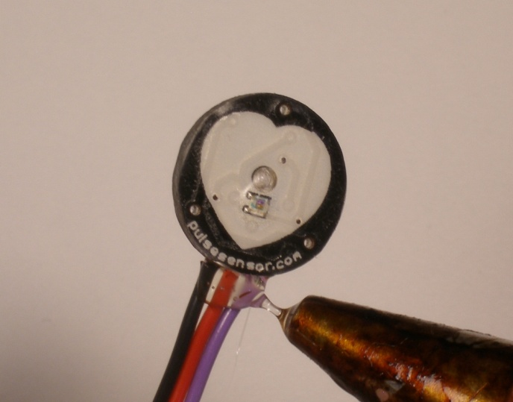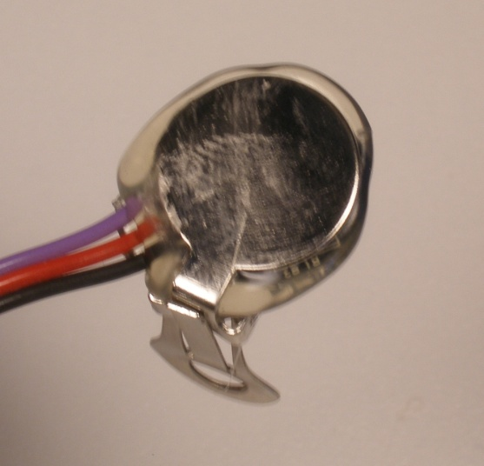

Allow the hot glue to ooze out around the ear clip. That will ensure good coverage. Take care not to let the hot glue cover around the ear clip hinge, as that could get in the way of it working. Trimming is easy with nail clippers (as above) or your trimming tool of choice. Don’t trim the wires by mistake!!!

让热胶从耳夹周围渗出来。这将确保良好的覆盖面。小心不要让热胶覆盖耳夹铰链周围，因为这可能会妨碍它的工作。用指甲钳(如上)或你选择的修剪工具修剪很容易。不要误剪电线!!

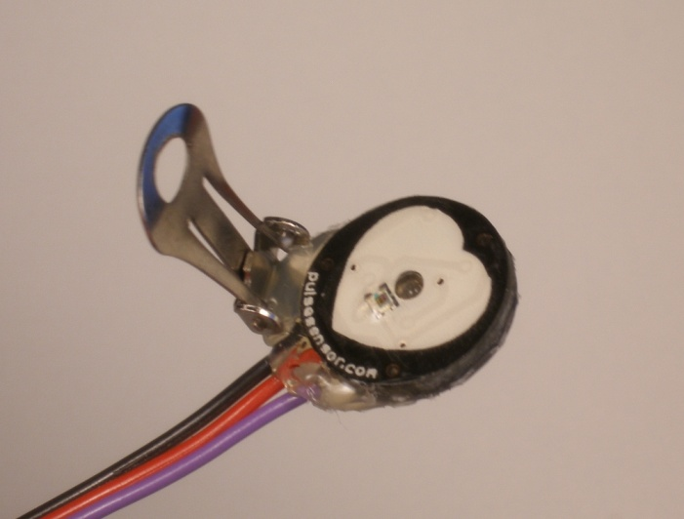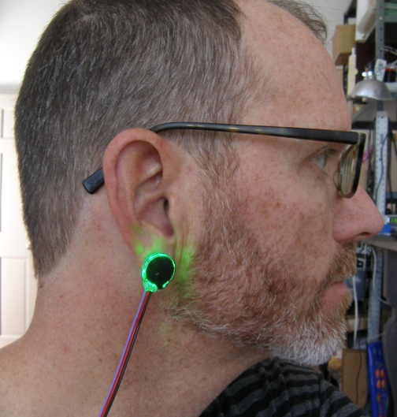

Hot glue is also great because it is easy to remove or re-work if you need to.

热胶也很好，因为它很容易删除或重新工作，如果你需要。